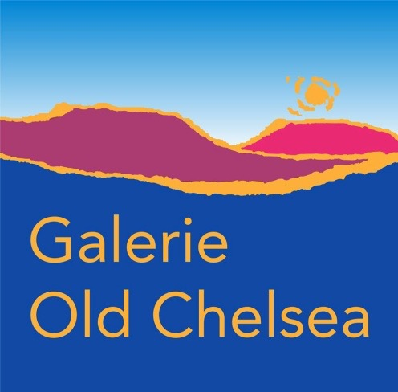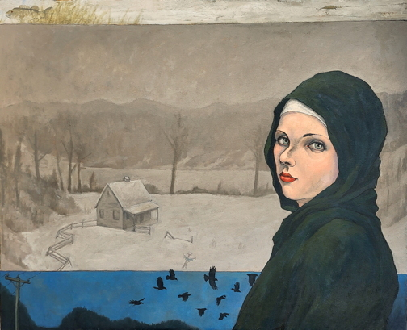
A Quorum of Sorrows by Reid McLachlan

FOR IMMEDIATE RELEASE
“A Murmuration of Whispers” by Reid McLachlan
Galerie Old Chelsea, Chelsea, Quebec
April 30 to May 17, 2026
Vernissage: Saturday May 2, 1-4 pm
Galerie Old Chelsea is thrilled to welcome Chelsea’s Reid McLachlan with “A Murmuration of Whispers”, a compelling new body of work that offers a rare glimpse into his creative process. McLachlan’s paintings begin not with images, but with words. Whether fragments, phrases, or complex thoughts, his visual language emerges from an incessant, shape-shifting murmuration of internal dialogue. “A Murmuration of Whispers” is a conspiracy of letters, words, and symbols that whir overhead swooping and diving, mutating into ephemeral hopes, fugitive worries, and tenacious regrets.
Each piece originates in a chaotic blur of whispered text—amorphous as smoke in the breeze—twisting and turning until form begins to coalesce. From this shifting terrain, visual narratives surface: solitary figures drift through silent, indifferent landscapes, searching for connection. Along their journeys, they encounter enigmatic forces—trickster ravens, counterfeit constellations, unreliable Madonnas, and other meddlesome presences—that guide or mislead them in equal measure. These figures, suspended in a timeless world of longing and regret, seek love and redemption while navigating a delicate balance between the conscious and subconscious. …/2
-2-

McLachlan’s paintings reveal deeply personal reflections on life, love, and loss, while resonating with a broader, shared humanity.
Reid McLachlan studied at the Ontario College of Art and Design, completing his final year at the OCAD campus in Florence, Italy. He graduated with Honours winning multiple awards in 1987. For over 35 years, he has lived and worked full-time in Chelsea, where he remains an active member of the Chelsea/Wakefield artistic community. His work has been featured in numerous solo exhibitions at both public and private galleries, including Galerie Montcalm, Art-Image, Karsh-Masson, l’Imagier, the Ottawa School of Art, Cube Gallery, and La Petite Mort.
Galerie Old Chelsea, which features local artists, is located in the beautiful Gatineau Hills above award-winning Les Fougères restaurant situated at 783 route 105, Chelsea, Québec, J9B1P1.
www.galerieoldchelsea.ca; Facebook: Galerie Old Chelsea (on Route 105, not on Scott)
For information contact Anne Swiderski at 819 827 8504 at swiderski.anne@gmail.com.

