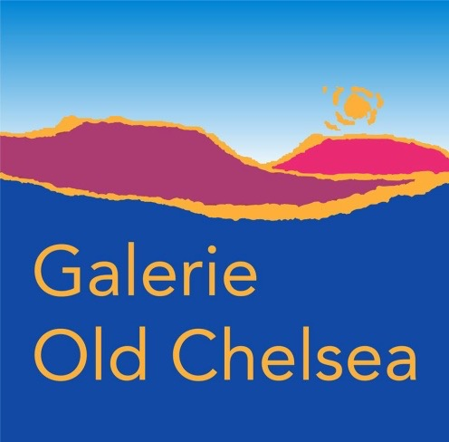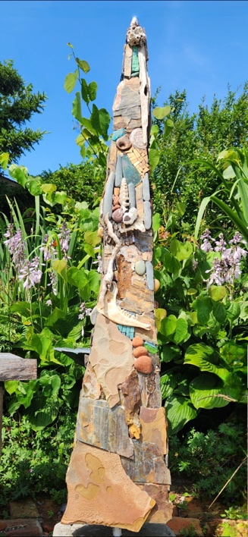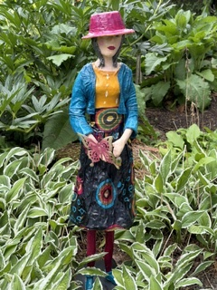
Pilar 1” by Carole Ludham Butterfly Dreams, by Mary-Lou Devine

Garden Sculpture Show by the National Capital Region Sculptors
Galerie Old Chelsea in the Les Fougères, Chelsea, Québec
August 22 & 23 August 2026
Saturday noon to 6, Sunday noon to 5 pm
Art and nature come together this August as Galerie Old Chelsea proudly presents a Sculpture Garden Show featuring the work of artists from the National Capital Region of Sculptors. Taking place August 22 and 23 in the beautiful gardens of Les Fougères Restaurant, the exhibition showcases contemporary outdoor sculpture created by artists from both Quebec and Ontario.
Visitors will discover an inspiring collection of sculptures crafted in a wide range of media, including wood, metal, fiber, and mosaic. Set throughout the restaurant's landscaped gardens, the exhibition offers a unique opportunity to experience sculpture in an outdoor setting where art and nature complement one another.
All sculptures are available for purchase and are designed to withstand the Canadian climate, making them ideal additions to outdoor gardens and landscapes.
Show Hours
- Saturday, August 22: 12:00 p.m. – 6:00 p.m.
- Sunday, August 23: 12:00 p.m. – 5:00 p.m. …/2
-2-

Featured Artists
Carole Andrée Lulham – Mosaics in Nature (Aylmer, Quebec / Saint John, New Brunswick)
Contemporary mosaic artist Carole Andrée Lulham creates expressive works using natural stone, glass, and found objects. Working with traditional Byzantine mosaic techniques interpreted in a contemporary style, she produces durable outdoor pieces inspired by the landscapes and places she explores. Her mosaics tell stories rooted in both the natural and built environment, often incorporating materials discovered along beaches, streams, abandoned sites, and roadsides.
Jack Stekelenburg (Renfrew, Ontario)
Metal sculptor Jack Stekelenburg is the founder of Walden Three Studio. Following a career of more than 50 years in the construction industry, he now creates contemporary sculptures from reclaimed steel and found industrial objects. His work has been exhibited throughout the Ottawa Valley and beyond. Through both his sculpture and workshops, Jack encourages viewers and participants to slow down, reflect, and discover their own creative voice.
Olga Kay-Grigoriev (Val-des-Monts, Quebec)
Working from her studio in Val-des-Monts, Olga Kay-Grigoriev transforms fallen trees from her property and the surrounding Gatineau Hills into expressive wood sculptures. Her rustically carved figures draw inspiration from life, nature, and the enduring character of the forest.
Mary Lou Devine (Ottawa, Ontario)
Mary Lou Devine creates sculptural works primarily with fabric, often combining textiles with resin, found objects, paper, clay, and other materials. Fascinated by the human figure throughout every stage of life, her sculptures explore gesture, emotion, and the shared experiences that connect us.
Gerry Heney, of PGH Assemblages (Ottawa, Ontario)
Gerry has had a lifelong fascination with art and design. An active member of the Ottawa art scene and a frequent gallery visitor, he draws inspiration from both local artists and international figures such as Louise Nevelson, Marcel Duchamp, Gérard Cambon, and Pablo Picasso.
​
Over many years, Gerry collected found objects whose form, texture, and colour spoke to him—pieces from a bygone era that once served …/3
-3-
practical purposes but are now relics of history. Rusted machinery, automotive parts, farm tools, and fragments of toys or games find new life in assemblage sculptures that blend whimsy, nostalgia and invention, inviting viewers to see beauty in the worn and forgotten.
The Sculpture Garden Show celebrates the creativity and diversity of sculptors working throughout the National Capital Region while offering visitors an exceptional opportunity to view and purchase original outdoor sculpture in one of the area's most beautiful garden settings.
Whether you are an experienced collector, looking for a unique addition to your garden, or simply enjoy discovering local art, this special weekend exhibition promises an inspiring experience for all.
The Old Chelsea Gallery, which showcases local artists, is located in the beautiful hills of Gatineau, above the award-winning restaurant Les Fougères, at 783 Route 105, Chelsea, Quebec, J9B 1P1. www.galerieoldchelsea.ca; Facebook: Galerie Old Chelsea (on Route 105, not on Scott). For more information, please contact Anne Swiderski at Swiderski.anne@gmail.com 819 827 8504.

